This is draft of the definition of the table format
Written on 20110502

This draft was written because formalism need to be done to define the data base format. To do that we need to write set of rules that define the table structure. To define this a BNF notation need to be used.
The file that define this grammar is called DataBase.

grammar DataBase;

String : (CharLow
| CharUpp
| CharNum
| CharEsp)+
;
CharEsp : ' ';
SpecialChar : '0x7c';
EOL : '\r' '\n' | '\n';
CharLow : 'a'..'z';
CharUpp : 'A'..'Z';
CharNum : '0'..'9';
CharPonc : ',' | '.' | '?' | ';' | '.' | ':' | '/' | '(' | ')'
;
ColumnValue : (String | CharNum | SpecialChar)*;

ColumnName : String ;

TableStruct : TableHeader TableBody;

TableHeader : ColumnName ColumnSep TableHeader
| ColumnName EOL
;
TableBody : ColumnValue ColumnSep TableBody
| ColumnValue EOL
;

ColumnSep : '||'
;

The heck with that notatio, is that it define the structure but not the consistency. 2 columns as header can be defined but 3 or whatever column containing values can be ok too.
By the way Rail road diagrams were defined associated to this grammar:

Illustration 1: TableStruct

Illustration 2: TableHeader railroad definition

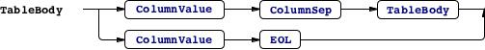Illustration 3: TableBody railroad definition

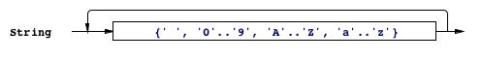Illustration 4: String railroad definition

Illustration 5: SpecialChar railroad definition

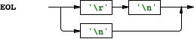Illustration 6: EOL railroad definition

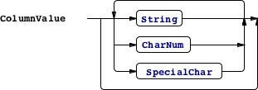Illustration 7: ColumnValue railroad definition

Illustration 8: ColumSep railroad definition

Illustration 9: ColumnName railroad definition

Illustration 10: CharUpp railroad definition

Illustration 11: CharPonc railroad definition
Illustration 12: CharNum railroad definition

Illustration 13: CharLow railroad definition
Illustration 14: CharEsp railroad diagram

